**Phần 1:**

1. docker --version



2. docker run hello-world

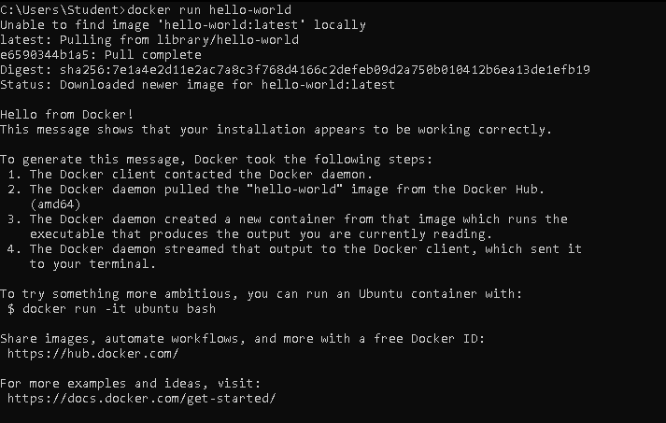

3. docker pull nginx

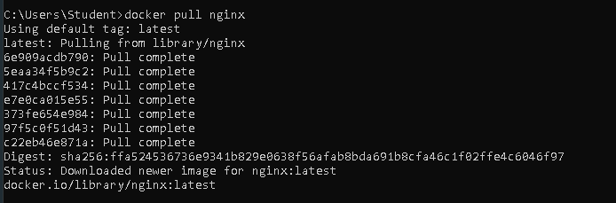

4. docker images

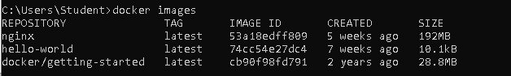

5. docker run -d nginx



6. docker ps



7. docker ps –a



8. docker logs <container_id>

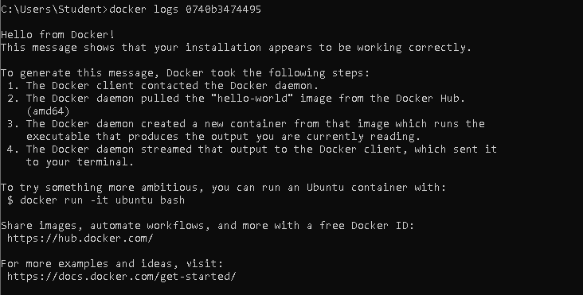

9. docker exec -it <container_id> /bin/sh

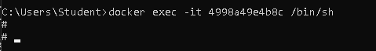

10. docker stop <container_id>



11. docker restart <container_id>



12. docker rm <container_id>



13. docker container prune

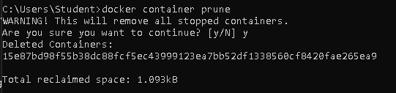

14. docker rmi <image_id>

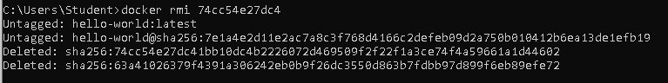

15. docker image prune –a

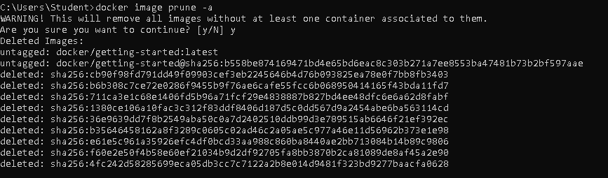

16. docker run -d -p 8080:80 nginx



17. docker inspect <container_id>

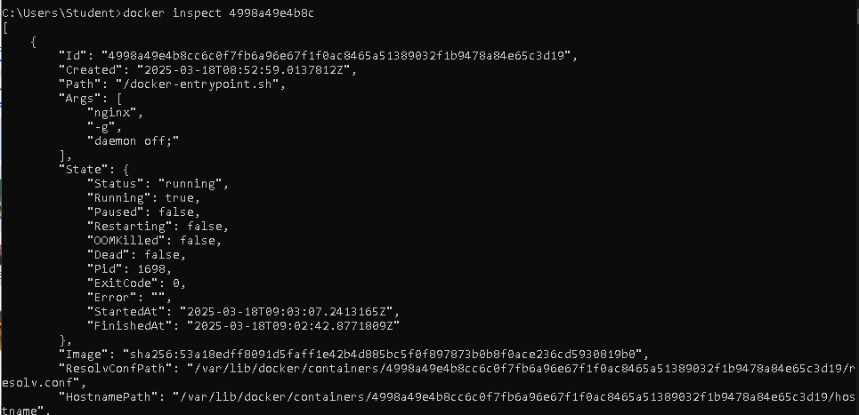

18. docker run -d -v mydata:/data nginx



19. docker volume ls



20. docker volume prune

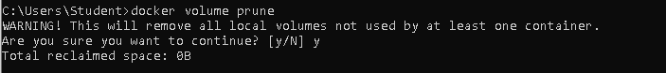

21. docker run -d --name my_nginx nginx



22. docker stats

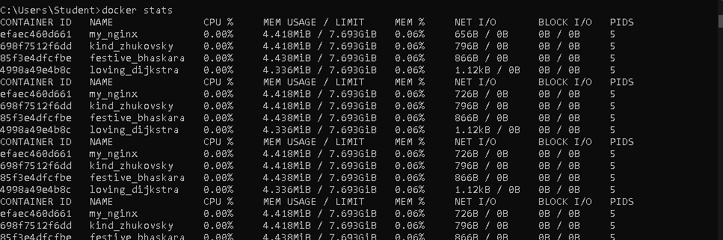

23. docker network ls

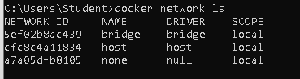

24. docker network create my_network



25. docker run -d --network my_network --name my_container nginx



26. docker network connect my_network my_nginx



27. docker run -d -e MY_ENV=hello_world nginx



28. docker logs -f my_nginx

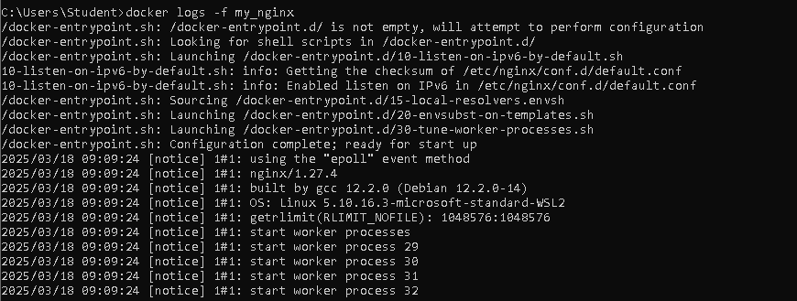

29. FROM nginx

COPY index.html /usr/share/nginx/html/index.html



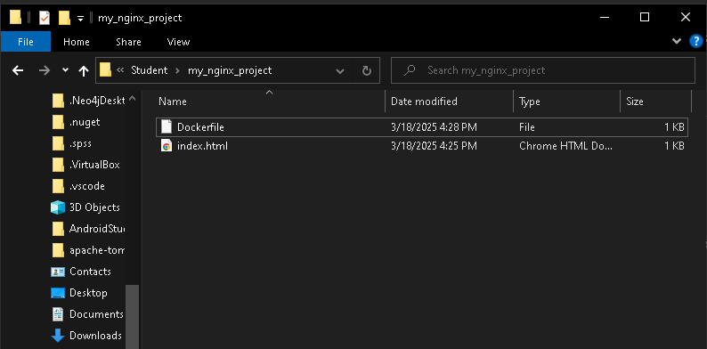

30. docker build -t my_nginx_image .

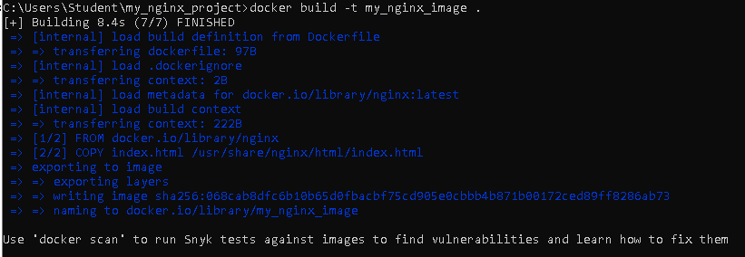

31. docker run -d -p 8081:80 my_nginx_image



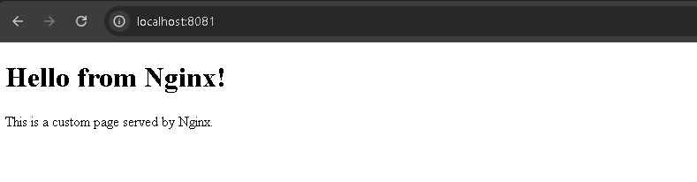

**Phần 2:**

Bài 1:

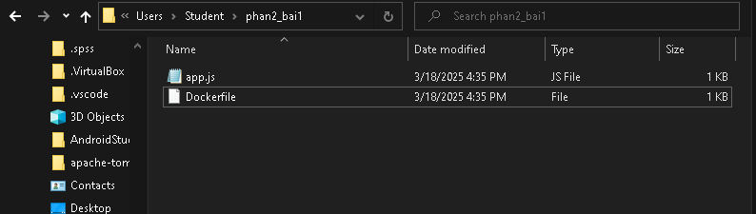

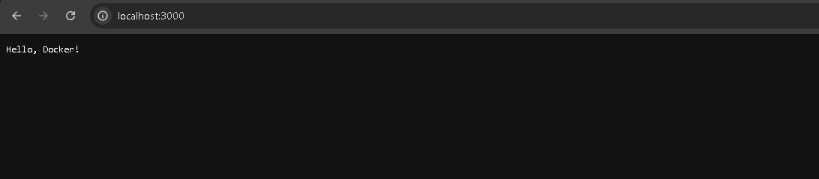

Bài 2:

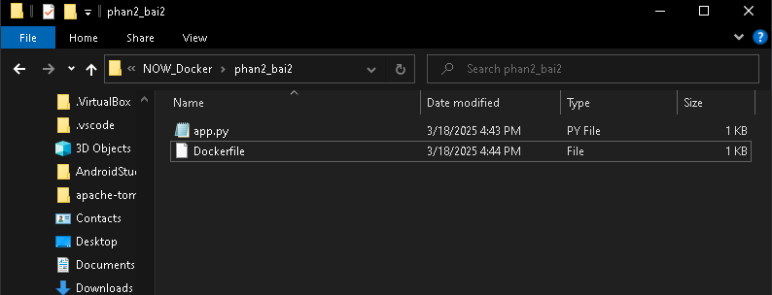

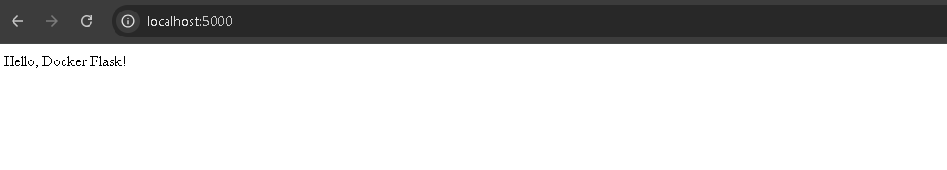

Bài 3:

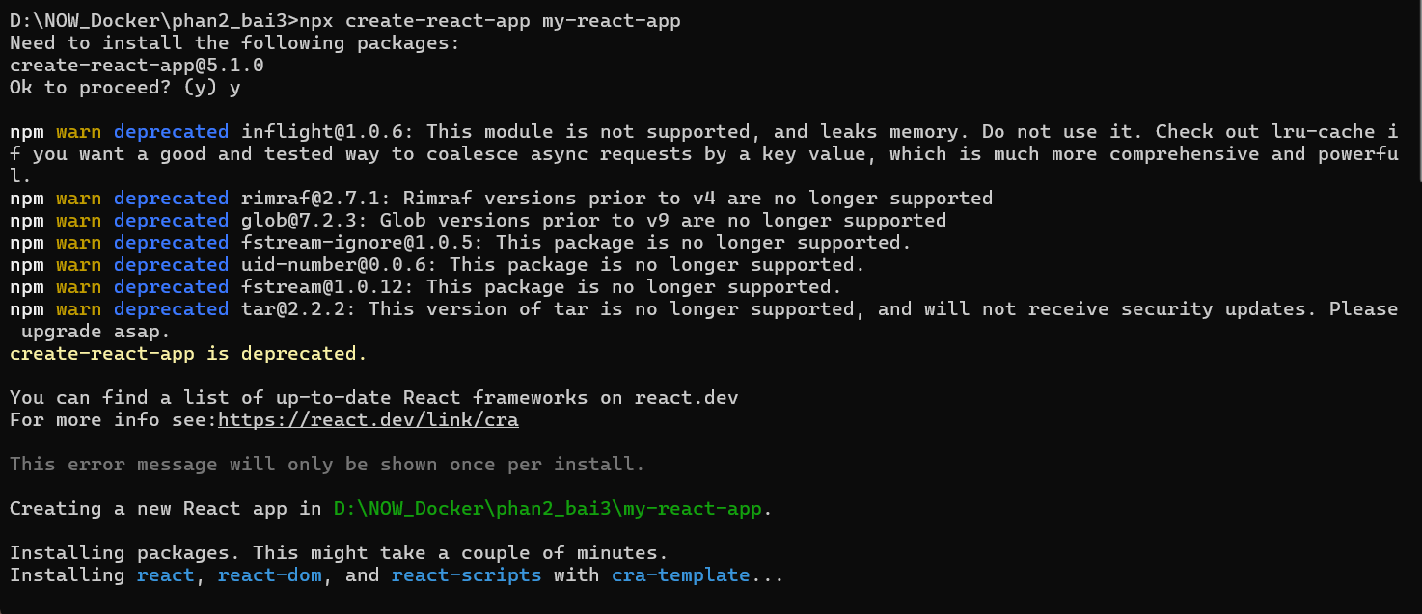

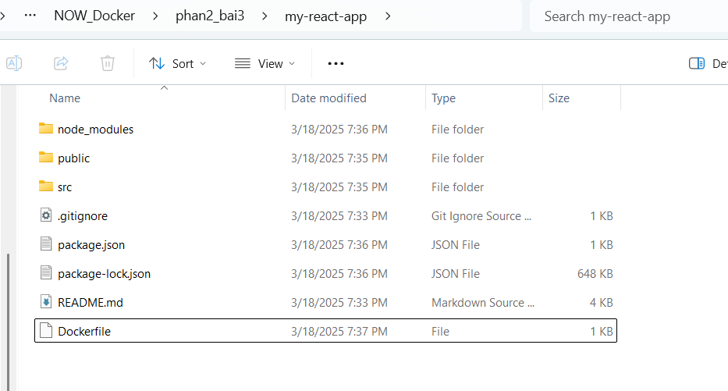

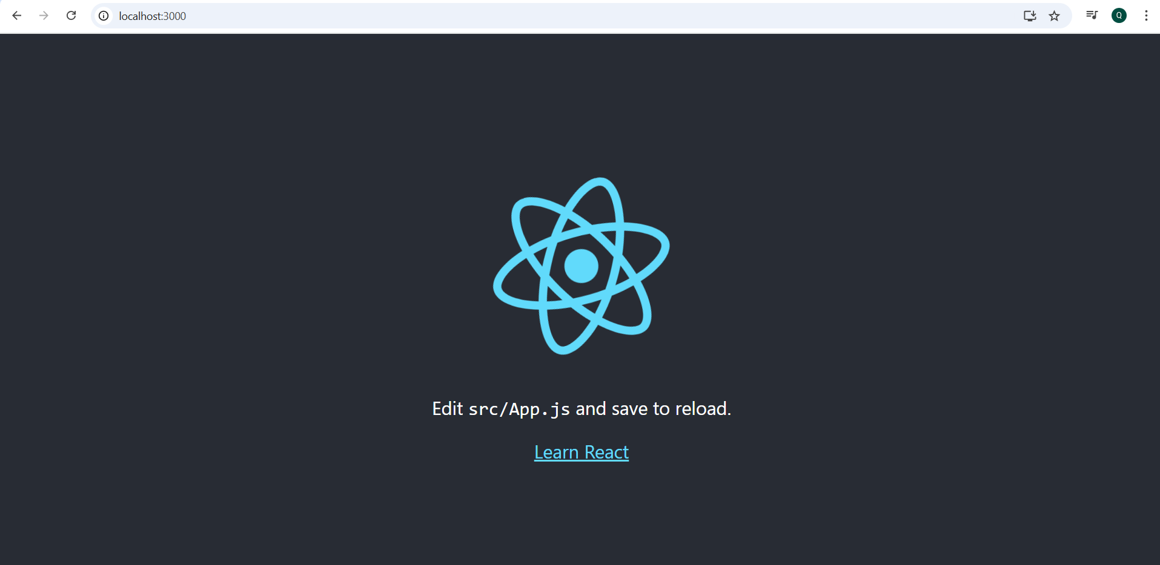

Bài 4:

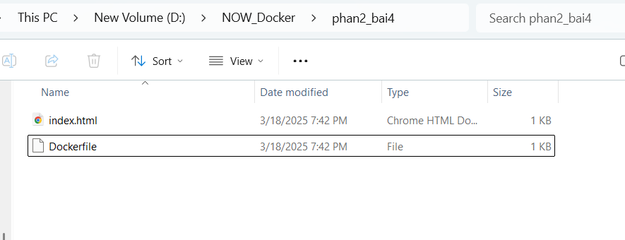

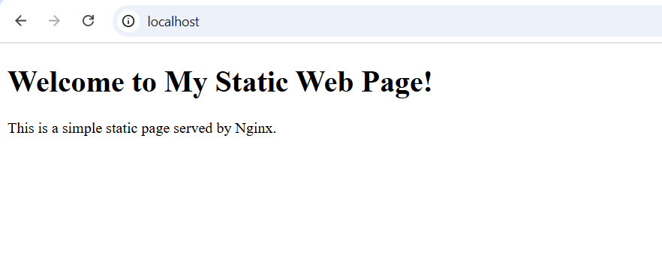

Bài 5:

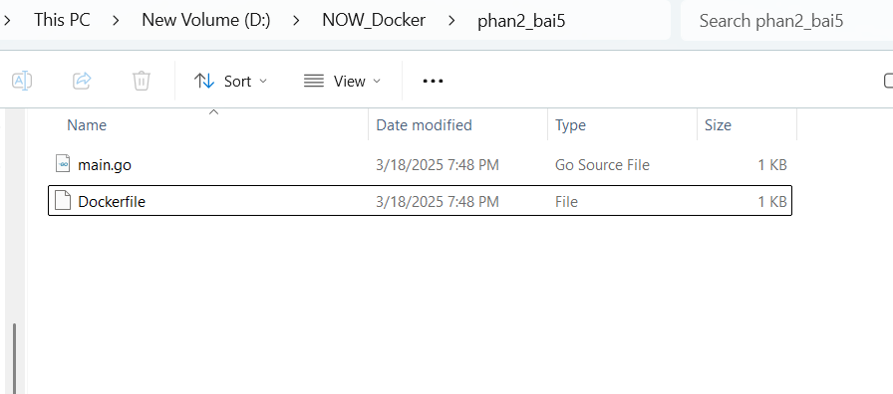

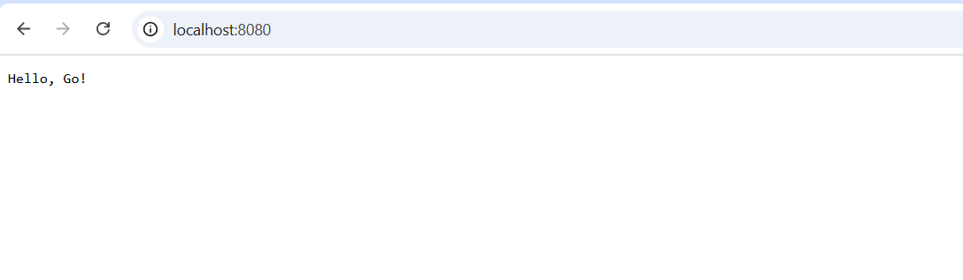

Bài 6:

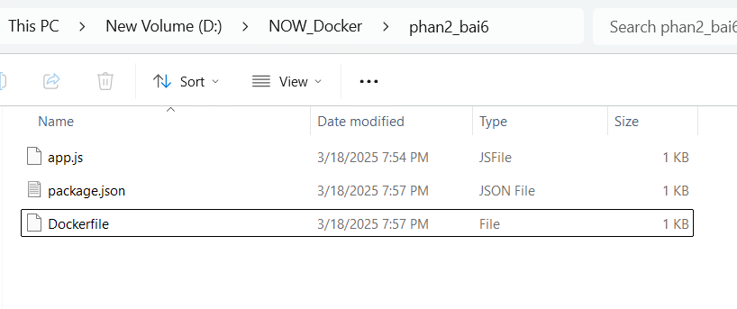

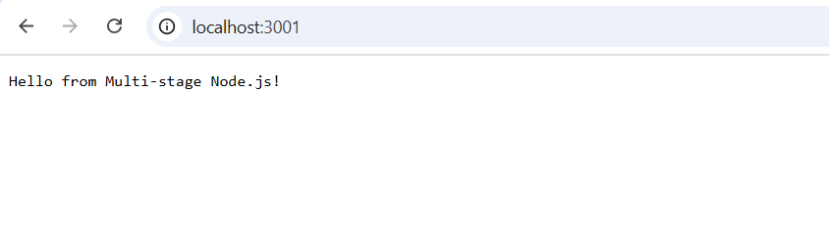

Bài 7:

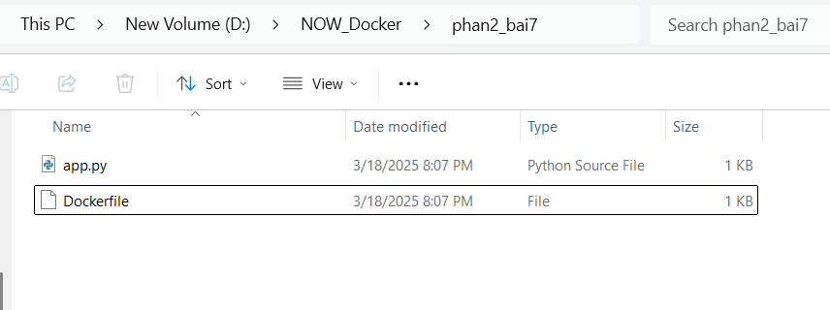

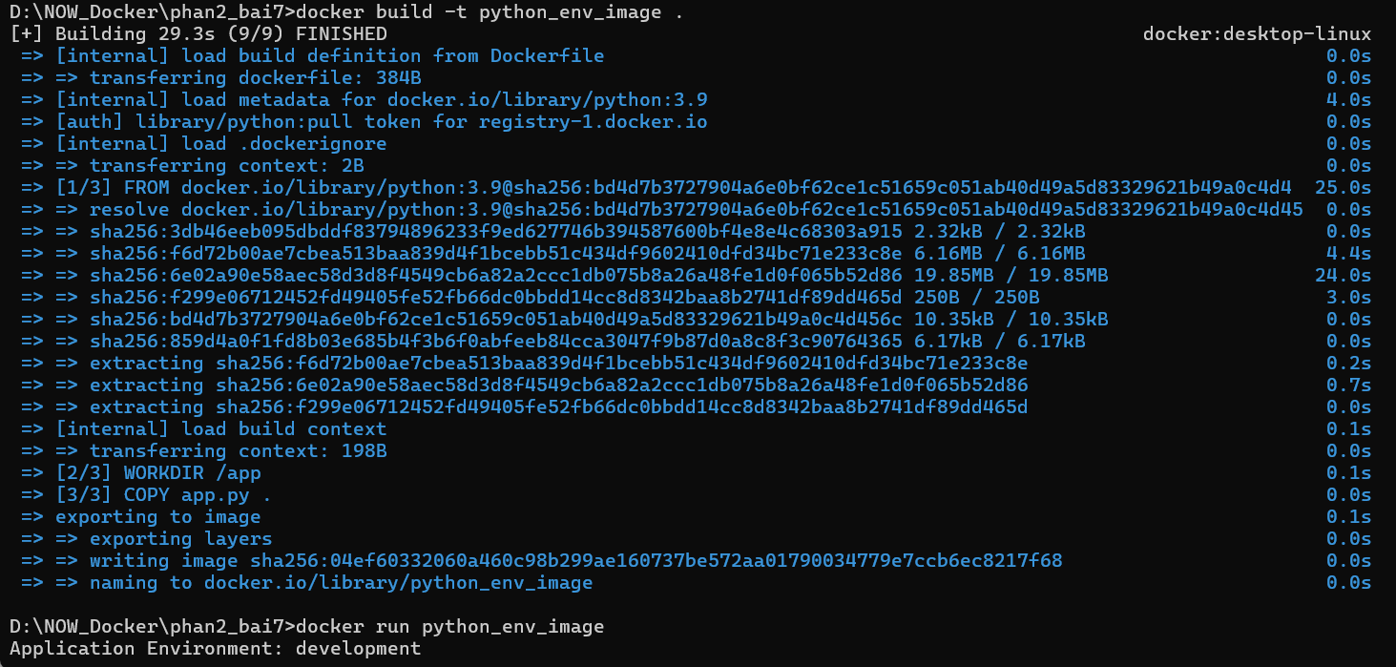

Bài 8:

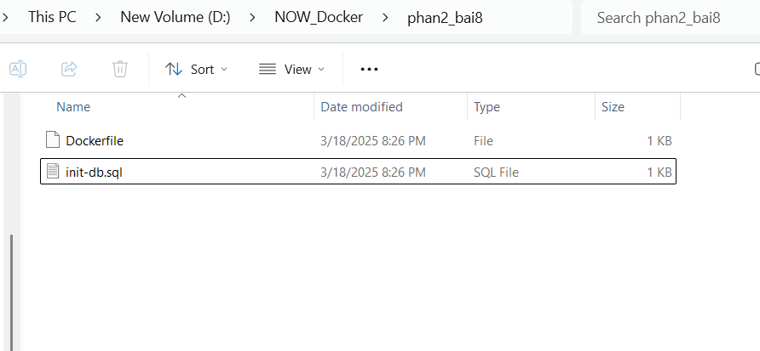



Bài 9:

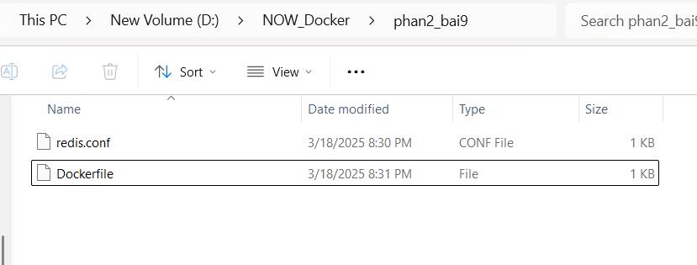



Bài 10:

